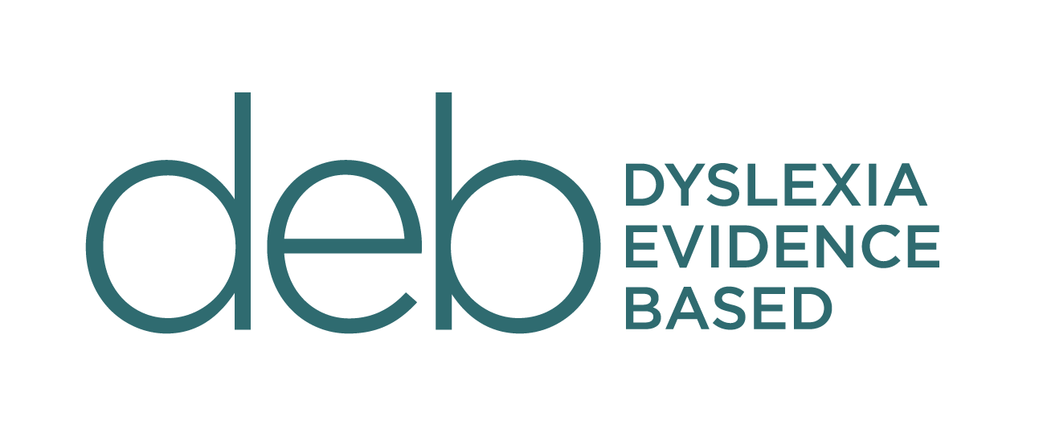

STUDENT PROFILE

This document helps condense all the information that’s in the reports and the knowledge you have of your own child. We all know it can get tiring repeating your story every year. This should make things easier for everyone involved.
The goal is to let the teacher read the document, process the information and then you can organise a meeting for the first or second week of school to discuss the contents and to work together to make a learning plan for the term/year.
The key is to keep it an overview of your child and not to overload it with too much information. This is not an IEP plan - it's a way of introducing your child to the teacher.

STUDENT PROFILE

OPTIONAL - INSERT PHOTO OF YOUR CHILD
Date: 22 February 2022
Name: Ben Evidence-Based
Age: 9yrs 8 months
Parents Names: Jean and Bob Evidence-Based

Diagnoses: Include suspected conditions – make it clear if those are unconfirmed. You may like to mention the school has a copy of all your child reports e.g. Woodcock-Johnson or APD etc.

Medications: If any – include what the medications are for. If medication is required during school hours, explain the process and timing in detail.

Hobbies/Motivators: Include activities the child enjoys, as well as what more generally motivates them – these will be helpful for the teacher when trying to engage and motivate the child, as well as help them to get to know the child better as an individual.

Strengths Challenges
etc etc
etc etc
etc etc
etc etc
Include academic subjects and personal/social attributes.
Things to list

Current Learning Supports
List all the roles of people involved in learning supports, such as private tutors, speech therapists, and occupational therapists. Give their names, contact details if you feel that is helpful/necessary, how often they see the child and what work they do with the child. If you are working on a programme at home with your child too, include yourself and the name of the programme/description of the intervention here as well.

Learning Plan
Explain here if there is a learning plan – such as an IEP – in place already. If there is not, you can leave this out, or you may want to use this space to express your desire for a formal learning plan to be put in place.

Accommodations
List any devices your child uses to assist their learning/concentration/ease anxiety etc. Also explain what behaviours or actions the teacher could use to help the child – for example, placing them close to the whiteboard during mat time, and repeating instructions that need to be kept to a 3-step maximum.
Briefly explain why/how each of these accommodations helps your child to learn so the teacher has buy-in. Include which subject areas these accommodations will be relevant in, for example that your child requires access to a typing device during Writing, audio books with headphones during "Silent Reading Time", and someone to read the word problems to them during math. This section can be organised either by the type of accommodation ('Device', 'Teacher Aide') or by the subject area ('Math', 'Writing'), or you could simply write up some paragraphs that summarise what your child requires in the classroom in order to succeed. Keep these short as you can go into more detail in your follow-up meeting.

Homework
Where possible, you would like your child’s homework to align with the skills they are learning with their tutor.

Extra Information
Explain any other preferences or information that you feel must be included which aren’t already covered above. For example: "Brian’s learning issues mean he is being taught an explicit, systematic, multi-sensory approach to literacy. This means Brian is taught a sound or spelling rule from his tutor/learning support each week or month and where possible we would love to incorporate this into his classroom. His poor vocabulary means wherever possible we try to increase this by discussing any unknown words." You may also want to mention Brian reads decodable books and you can supply books for the class.

This document was created by Sharon Scurr founder of the deb in October 2020 and updated December 2021

